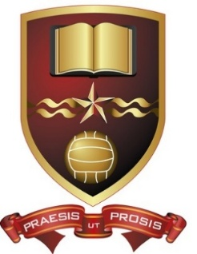
De La Salle College, Waterford
LCA 1 and LCA 2 Booklist 2026-2027

Subject LCA 1 LCA 2

Mathamatical LCA Maths 1 and 2 (2 Workbooks) LCA Maths 3 and 4 (2 Workbooks)
Applications Maths + Planning (Golden Key) Maths + Planning (Golden Key)

Communicative Irish Gaeilge Gach Ait (CJ Fallon)

English LCA today; English LCA today; English
Communication and Communication (Folens) and Communication (Folens)
Hotel, Catering None Needed None Needed
And Tourism

Social Education Social Ed for LCA
Ellis Flood (Gill)

Religion None Needed None Needed
Art, Craft and None Needed None needed
Design

Graphics and None Needed None Needed
Construction

IT Introduction to ICT 1for LCA Introduction to ICT 2 for LCA
(Golden Keys – D Evers-Nolan) (Golden Keys – D Evers-Nolan)
French To be decided when Available

Career Guidance a) Reach
b) Career Portfolio + Online Guidance
(By LCA Classroomguidance)

VPG Classroom Guidance Classroom Guidance
(Set of Workbooks) (Set of Workbooks)
Classroom Guidance.ie Classroom Guidance.ie

