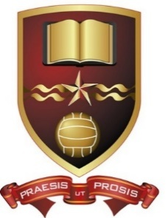
De La Salle College, Waterford

5th Year Booklist 2026-2027

Subject New 5thYear Syllabus

Maths New 2027 Text and Tests 3(OL)
Text and Tests 4(HL)

Irish New 2028 Fuinneamh
Fiuntas Nua

English Deferred to This is Poetry 2028(HL)
2027 Verse Poetry 2028(OL)

Chemistry New 2025 Chemistry Live 3rd Ed (Folens)

Physics New 2025 The Physics Book (CJ Fallon)

Biology New 2025 Biology Plus (Edco)

Ag. Science New 2027 Breaking Ground(3rd Ed.)(Edco)
Soft Cover Manuscript Copy

Business New 2025 Back in Business (GD Education)

Accounting Deferred to Accounting for Senior Cycle
2027 (4th Ed.)

Economics New 2028 Economics Now

French New 2028 Tout Va Bien (4th Ed.)(Folens)

Spanish New 2028 Espanol en Accion (Folens)
German New 2028 Aufs Kur(Educate.ie)

History New 2027 Modern Europe (4th Ed.)

Geography New 2026 Planet and People (4th Ed.)

Construction New 2026 Get Constructive 2nd Ed (Educate.ie)
(+ Skills and Assessment Books)

Applied Maths New 2029 Fundamental Applied Maths

DCG New 2027 Graphics in Design and Communication

Home Ec. New 2027 Complete Home Economics(2nd Ed.)
Food Studies Assignment Guide
Exam Skillbuilder Workbook.

Music New 2027 Soundcheck Set B(Edco)
Music Manuscript copy

Art New 2028 New Appreciating Art Visual Studies

LCW New 2026 Focus on Life, Community and Work (CJ Fallon)
(Life, Community and Work)

LC-PE New 2026 New Winning Formula 2nd Edition (Gill)

Computer Science New 2027 Computer Science for L.C.
(Golden Key)

Religion a) Pathways to purpose(Educate+)
b) Life matters (Mentor)

c) Manual for Spiritual Warfare
(by Paul Thigpen)

Career Guidance No Books - Careers Portal Reach
Individual Student code

